Information Extraction From Lapan Satellite Ais Database For Ship Classification In The Indonesian Territorial Waters
Muazam Nugroho¹, Nurrochman Ferdiansyah¹, Dicka Ariptian Rahayu¹,
Rizki Permala¹, Patria Rachman Hakim¹, Wahyudi Hasbi¹

¹Satellite Technology Center, National Institute of Aeronautics and Space (LAPAN), Indonesia
e-mail: muazam.nugroho@lapan.go.id
Received: ..... (DDMMYYY). Accepted: ..... (DDMMYYY). Publishied: ..... (DDMMYYY)
DOI: 10.30536/j.jtd.xxxxxxxxxxxx
Abstract

Automatic Identification System (AIS) is a system used to monitor ship activity by sending ship information via Very High Frequency (VHF) waves. Information sent by ships around the world is recorded by AIS receivers carried by the LAPAN-A2 and LAPAN-A3 satellites along their orbital trajectories. The AIS data recorded by the satellite will then be acquired and stored at the LAPAN earth station. This study focuses on extracting information from the LAPAN satellite AIS database to obtain information on the number of vessels based on a unique Maritime Mobile Service Identity (MMSI) grouped according to the type of vessel entering Indonesian waters with coordinates 95BT / 141BT, -11LS / 6LU every month. in the period January to December 2019. The results of extracting the information are in the form of the number of ships based on unique MMSI which are grouped according to the type of ship in the territory of Indonesia with that region and time period.

Keywords: AIS, database, LAPAN satellite, marine traffic

1. Introduction
Indonesia's territory, which is a vast archipelago, requires a good maritime surveillance system. The National Aeronautics and Space Agency (LAPAN) participated in Indonesia's maritime surveillance by launching two micro satellites containing the AIS Automatic Identification System (AIS) receiver, namely the LAPAN-A2 satellite in 2015 and LAPAN-A3 in 2016. The LAPAN-A2 satellite has a near-equatorial orbit with an altitude of 650 km while the LAPAN-A3 satellite has a sun-synchronous polar orbit with an altitude of 515 km. LAPAN-A2 with its orbit allows it to pass through Indonesian territory 14 times a day, while the polar orbit on the LAPAN-A3 satellite allows for global coverage (Karim, 2018). With these different types of orbit, the two satellites could complement each other's AIS data recorded by each satellite.
Automatic Identification System (AIS) is a technology used for monitoring of ship traffic around the world. AIS operates on the VHF channel with a frequency of 161,975 MHz and 162,025 Mhz for the purpose of sending and receiving ship-specific information (ITU, 2012). Some of the information obtained from the AIS system includes Maritime Mobile Service Identity (MMSI), Position, Course, Call Sign, and AIS base station (Hu, 2012). AIS devices operate using a time division multiple access (TDMA) system, which makes it possible to send around 2000 reports per minute (Stupak, 2014). Messages sent by AIS devices from ships can be received by fellow ships, terrestrial-based AIS receiving stations, and satellite-based AIS receiving stations (space-borne AIS). The space-borne AIS has an advantage in the radius of receiving AIS messages because of its height (Ball, 2013). The LAPAN-A2 satellite with its near-equatorial orbit receives AIS messages around the equatorial line, while with its polar orbit, the LAPAN-A3 satellite receives AIS messages which are more evenly distributed around the world.
This research focuses on extracting information from the AIS LAPAN database to obtain information on the number of vessels based on unique MMSI which are grouped according to the type of ship entering Indonesian waters with coordinates 95BT / 141BT, -11LS / 6LU in the period January to December 2019. The purpose of This paper is to provide an overview of the classification of ships passing in Indonesian territorial waters during that time period.

2. Methodology
It is explained in the IMO document (2002) that AIS information transmitted by ships has four different types with different transmission times:
1. Static Information, which is information entered during the installation of AIS onboard and can also be changed if there is a change in the legal documents of the ship, such as a change in the name and ownership of the ship.
2. Dynamic Information, which is information that contains the ship's navigation status which will automatically change according to the data obtained from sensors connected to the AIS tool.
3. Sailing information, which is information entered and updated manually by the crew.
4. Short safety-related messages.
Details of the AIS information can be seen in the following figure:
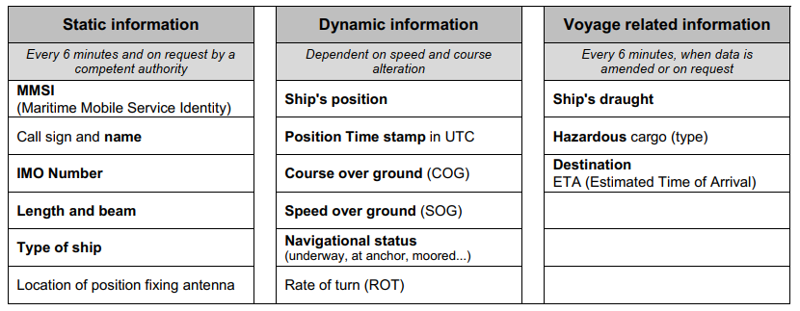
Figure 2-1: information transmitted by ship (IMO 2002)

In static information there is a field of MMSI (Maritime Mobile Service Identity) which is a unique code for the ship. The making of the MMSI code is regulated in the ITU-R M.585-8 document, it explains that the MMSI code has a nine-digit length with the format M₁I₂D₃X₄X₅X₆X₇X₈X₉ where the initial three digits represent the code of origin of the ship's country. Static information and shipping information are transmitted every 6 minutes or when there is a request from the authorities while for dynamic information the transmission interval is carried out according to the status and speed of the ship:
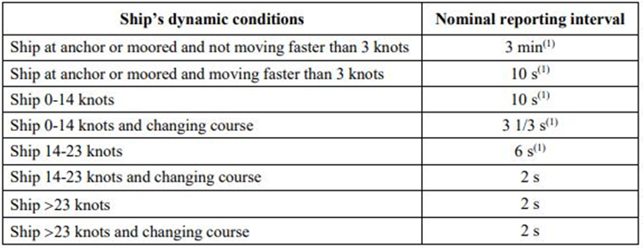
Figure 2-2: transmission data interval
2.1. Database Processing
As previously mentioned, LAPAN-A2 and LAPAN-A3 satellites carry the AIS receiver payload into orbit. LAPAN-A2 satellite in near-equatorial orbit receives AIS messages around the equatorial line, while with its polar orbit, LAPAN-A3 satellite receives AIS messages which are more evenly distributed around the world. The data stored in the satellite is routinely acquired by the earth station and stored in a database management system. The AIS data from these two satellites are stored in different databases. For the purposes of utilization, AIS data from separate databases are combined to complement each other in order to obtain more complete information.
The reason for using a database system to store data is that the database offers speed, accuracy, reporting, and thoroughness as its advantages (Suehring, 2002). To store satellite AIS data into a database, a Database Management System (DBMS) is required. MySQL is a DBMS with a relational system, also known as a relational database management system (RDBMS). Relational databases store data in separate tables (MySQL, 2021).
In the database, AIS messages are separated into tables based on the type of information. Dynamic messages (which have position coordinate fields) are entered in the Position Report table, whereas static messages are entered in the static table. The purpose of this paper is to obtain information on ship types in a certain area and at a certain time, then the information needed is the position data, the time contained in the position report table and the ship type data in the static table.
The method used in this study focuses on processing the AIS database for the LAPAN-A2 and LAPAN-A3 satellites. A summary of the research methods is described below:

2.1.1. Database Merging
The AIS database for the LAPAN-A2 and LAPAN-A3 satellites is combined into a new database. The table format in the database is made exactly the same as the database before it is merged. What is different is that the new database contains AIS messages originating from the LAPAN-A2 and LAPAN A3 satellites, and the information period is grouped into monthly period.
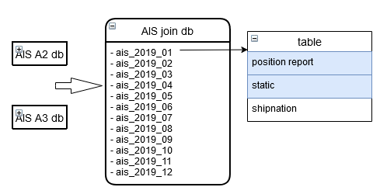
Figure 2-2: Merging of the AIS database for the LAPAN-A2 and LAPAN-A3 satellites

2.1.2. Views Creation
In a MySQL database, a view can be defined as a virtual table. The contents of this table can come from other tables or a combination of several tables. The purpose of creating a View is to make it easier to write queries and speed up data display, especially if the query is repeated (DuBois, 2014). In this study, making a view from each monthly database aims to retrieve the ship type information in the static table into the location message row in the Position Report table.
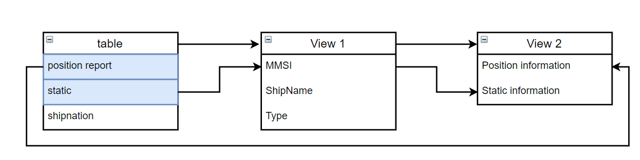
Figure 2-3: Creation of Views on the LAPAN satellite AIS database
There are 2 views created. The first view (View 1) contains a list of ships with unique information on MMSI, ship name, and vessel type. This information is obtained from a static table. The second view (View 2) contains a combined data from the Position Report table with data from View 1 based on MMSI. This combination will provide information on the ship's position complete with the name and type of ship. Data from View 2 is what data retrieval and analysis is carried out.

2.1.3. Data Cleansing
Filter queries use distinct on a static table to filter MMSI, ship name and type so there is no duplication, in other words, only 1 unique MMSI value represents 1 ship. Furthermore, the max (time) filter is applied in the Position Report table to obtain a more valid vessel type.

2.1.4. Creation of Views from multiple time periods
Static information in the database is usually incomplete, which is no static information from the MMSI in the Position Report information, which will cause the ship type to be unknown / NULL. This could be due to not receiving messages from the ship or errors during the transmission of AIS messages.

Table 2-1: Period of analyzed Position Report data and static data
no | Position Report | Static Data 1 month | Static Data 3 months | Static Data 1 year
1 | Jan-19 | Jan-19 | Jan, Feb, Mar 2019 | Jan - dec 2019
2 | Feb-19 | Feb-19
3 | Mar-19 | Mar-19
4 | Apr-19 | Apr-19 | Apr, May, Jun 2019
5 | May-19 | May-19
6 | Jun-19 | Jun-19
7 | Jul-19 | Jul-19 | Jul, Aug, Sep 2019
8 | Aug-19 | Aug-19
9 | Sep-19 | Sep-19
10 | Oct-19 | Oct-19 | Oct, Nov, Dec 2019
11 | Nov-19 | Nov-19
12 | Dec-19 | Dec-19

In this study, a view was made of creating views by taking static information from several different time periods, namely the period of one month, 1 quarter, and 1 year. The purpose of retrieving static information from several time periods is to see how much influence the static information period has on the completeness of the data. The initial hypothesis is that the greater the static data period, the more complete the information will be. Table 2-1 describes the data period analyzed.
To combine the information in separate tables, a field is needed in both tables. This field is the MMSI (Maritime Mobile Service Identity) field. Here are the relationships between tables to produce the desired information:
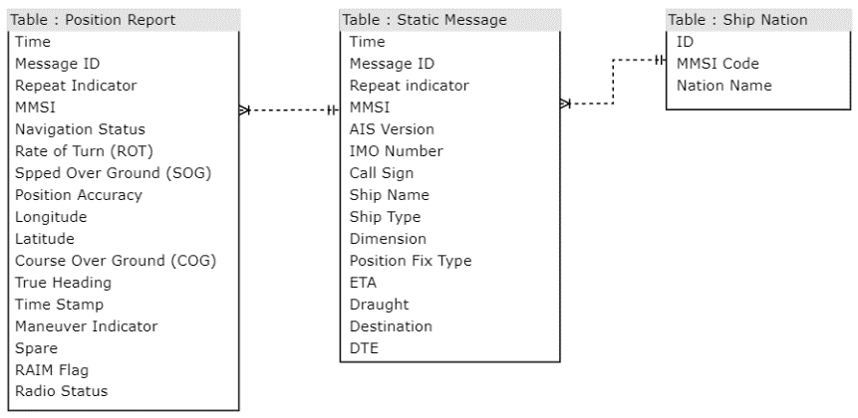
Figure 2-4: Relationships between tables in a database

2.2. Information Retrieval from the Database
Data retrieval is done by performing a MySQL query to calculate the number of unique MMSIs with time and region filters according to the needs. The following is the MySQL query used:

mysql> | SELECT type, COUNT(*) FROM (select * from View2 where date(time) >='2019/01/01' and DATE(time)<='2019/01/31' and (lattd>=-11 and lattd<=6) and (longtd>=95 and longtd<=141) )  AS A JOIN  (select distinct mmsi, max(time) AS time from PositionReport where date(time)>= '2019/01/01' and DATE(time)<='2019/01/31' and (longtd>=95 and longtd<=141)  and (lattd>=-11 and lattd<=6) group by mmsi) AS B ON A.MMSI=B.mmsi AND A.Time=B.Time GROUP BY type;

This query will generate a number of unique MMSIs at a predetermined time and region with the vessel type of the MMSI.

3. Result And Discussion
After going through the data selection and classification process, the AIS satellite LAPAN-A2 and LAPAN-A3 data were obtained in the 95BT / 141BT, -11LS / 6LU areas in the period January to December 2019 which had the following data:
- Ship Classification data with 1-month static data period
The following is the number of vessels by type in the period from January to December 2019 in the area 95BT / 141BT, -11LS / 6LU with static data for a period of 1 month:
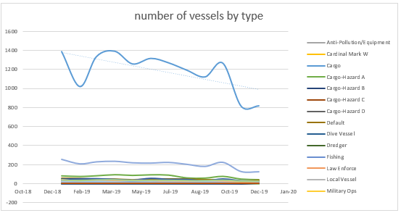
Figure 3-1: Graph of the number of vessels by type with a static data period of 1 month (without nulls)
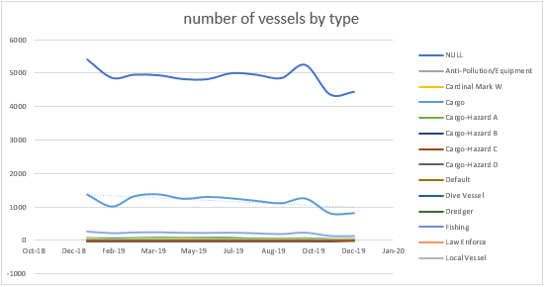
Figure 3-2: Graph of the number of vessels by type with a static data period of 1 month (with nulls)
From the graph above, it can be seen that the top 3 types of vessels are the unknown ship type (NULL), cargo type, and tanker type. Table 3-1 shows details of the number of unique MMSIs based on the 3 types of vessels:
Table 3-1: number of unique MMSIs from top 3 vessel type
 | Ship Type
month | NULL | Cargo | Tanker
Jan-19 | 5425 | 1386 | 251
Feb-19 | 4862 | 1021 | 204
Mar-19 | 4957 | 1334 | 225
Apr-19 | 4938 | 1390 | 231
May-19 | 4822 | 1257 | 215
Jun-19 | 4821 | 1315 | 212
Jul-19 | 5004 | 1269 | 219
Aug-19 | 4954 | 1192 | 199
Sep-19 | 4852 | 1122 | 177
Oct-19 | 5256 | 1265 | 220
Nov-19 | 4353 | 816 | 123
Dec-19 | 4434 | 820 | 121

- Ship Classification data with 3-month static data period
The following is the number of vessels by type in the period from January to December 2019 in the area 95BT / 141BT, -11LS / 6LU with static data for a period of 3 month:
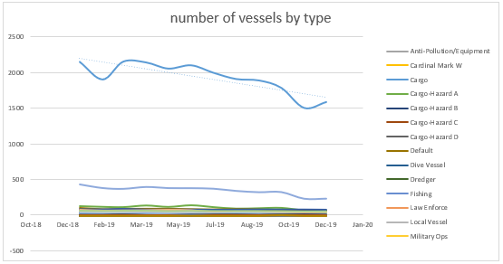
Figure 3-3: Graph of the number of vessels by type with a static data period of 3 month (without nulls)
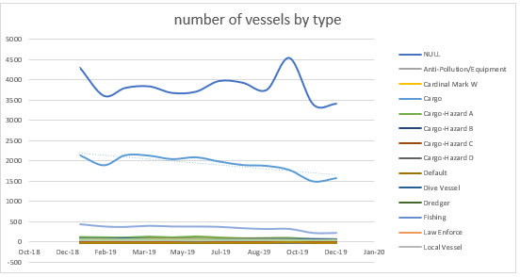
Figure 3-4: Graph of the number of vessels by type with a static data period of 3 month (with nulls)

From the graph above, it can be seen that the top 3 types of vessels are the unknown ship type (NULL), cargo type, and tanker type. Table 3-2 shows details of the number of unique MMSIs based on the 3 types of vessels:
Table 3-2: number of unique MMSIs from top 3 vessel type
 | Ship Type
month | NULL | Cargo | Tanker
Jan-19 | 4291 | 2148 | 428
Feb-19 | 3605 | 1902 | 378
Mar-19 | 3800 | 2152 | 367
Apr-19 | 3838 | 2140 | 393
May-19 | 3677 | 2054 | 377
Jun-19 | 3707 | 2100 | 376
Jul-19 | 3969 | 1996 | 369
Aug-19 | 3928 | 1908 | 338
Sep-19 | 3747 | 1888 | 320
Oct-19 | 4535 | 1785 | 322
Nov-19 | 3393 | 1504 | 230
Dec-19 | 3411 | 1586 | 231

- Ship Classification data with 1-year static data period
The following is the number of vessels by type in the period from January to December 2019 in the area 95BT / 141BT, -11LS / 6LU with static data for a period of 1 year:
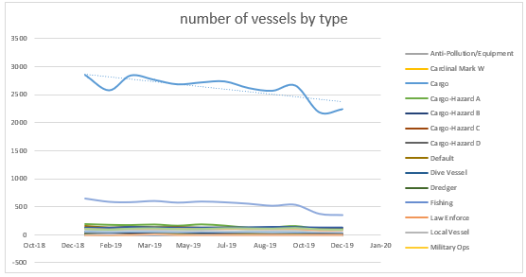
Figure 3-5: Graph of the number of vessels by type with a static data period of 1 year (without nulls)
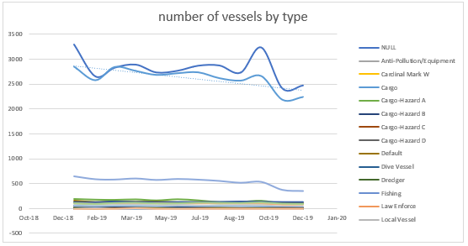
Figure 3-6: Graph of the number of vessels by type with a static data period of 1 year (with nulls)

From the graph above, it can be seen that the top 3 types of vessels are the unknown ship type (NULL), cargo type, and tanker type. Table 3-3 shows details of the number of unique MMSIs based on the 3 types of vessels:

Table 3-3: number of unique MMSIs from top 3 vessel type
 | Ship Type
month | NULL | Cargo | Tanker
Jan-19 | 3290 | 2845 | 651
Feb-19 | 2652 | 2574 | 591
Mar-19 | 2824 | 2837 | 584
Apr-19 | 2887 | 2759 | 606
May-19 | 2730 | 2680 | 576
Jun-19 | 2764 | 2714 | 596
Jul-19 | 2865 | 2732 | 582
Aug-19 | 2870 | 2615 | 556
Sep-19 | 2726 | 2566 | 518
Oct-19 | 3231 | 2658 | 536
Nov-19 | 2408 | 2185 | 371
Dec-19 | 2470 | 2240 | 348

4. Conclusion
By utilizing the AIS data in the database, we can get some statistical information on ships that are in Indonesian waters in the period from January to December 2019. Before this information can be obtained, it needs to be processed first in the database, one of which is by creating a view / relation table so that the data obtained to be complete.
In this study, information extraction on AIS satellite data for the classification of ship types has been completed. The result of extracting this information is that the greater the period of static data, the lesser the ship type is unknown / null, the average percentage of ship types null is 73.76% for a static data period of 1 month, 56.93% for a static data period of 3 months, and 39.58% for static data for a period of 1 year. In the period from January to December 2019, the largest type of ship was cargo, and it can be seen that the number of cargo ships has a downward trend along the year of 2019.

Acknowledgements
Authors sincerely appreciate Mr. Ir. Mujtahid, M.T. as the Head of Satellite Technology Center and LAPAN Satellite’s operators for their support regarding AIS data used on this research.
Reference

A. Karim, R. Permala, M. Mukhayadi, W. Hasbi, "LAPAN-A2 and LAPAN-A3 Automatic Identification System (AIS) Satellitte Data Correction using Interpolation and Extrapolation Method," Jurnal Teknologi Dirgantara vol. 16 no.2 December 2018
International Telecommunications Union. Interim Solutions for Improved Efficiency in the Use of the Band 156–174 Mhz by Stations in the Maritime Mobile Service ; International Telecommunications Union: Budapest, Hungary, (2012)
Q. Hu, Yi Jiang, X. Sun, S. Zhang., “Development of Automatic Indetification System Autonomous Positioning System,”Journal Sensors, (2012)
T. Stupak, “Influence of Automatic Identification System on Safety of Navigation at Sea,” Journal of Marine Navigation and Safety of Sea Transportation Vol. 8 No. 3, 337-341, (2014)
Ball H., 2013. Satellite AIS for Dummies Special Edition. John Wiley & Sons Canada, Ltd. Mississauga. ISBN: 978-1-118-48494-4
IMO: Recommendation on Performance Standards for a ship-borne Automatic Identification System (AIS). MSC 74(69) Annex 12. London: IMO, 2002
Suehring Steve, 2002. MySQL Bible. Wiley Publishing, Inc. New York. ISBN: 0-7645-4932-4
https://dev.mysql.com/doc/refman/8.0/en/what-is-mysql.html retreived: 19 Maret 2021
DuBois Paul, 214. MySQL Cookbook, Third Edition. O’Reilly Media, Inc. Sebastopol, CA. ISBN: 978-1-449-37402-0

